### Certification and Approval of Annual Accounts for 2023-24

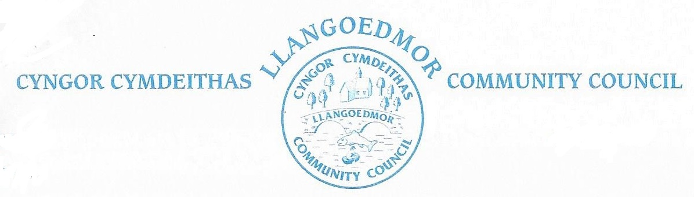

Regulation 15(1) of the Accounts and Audit (Wales) Regulations 2014 (as amended) requires that the Responsible Financial Officer of Llangoedmor Community Council sign and date the statement of accounts, and certify that it properly presents Llangoedmor Community Council’s receipts and payments for the year. The Regulations require that this be completed by 30th June 2024.

Due to the delay in filling the vacant post of Clerk and Responsible Financial Officer at Llangoedmor Community Council, which has subsequently resulted in a delay in the completion of the accounts, the Responsible Financial Officer has not signed and certified the accounts for the year ended 31st March 2024 by the above date. The statement of accounts will be prepared and the Responsible Financial Officer will sign and certify the statement of accounts after the successful completion of internal audit processes necessary for verification of the accounts.

Regulation 15(2) of the Accounts and Audit (Wales) Regulations 2014 (as amended) requires that following the certification by the Responsible Financial Officer referred to above, the Council must approve the accounts. The Regulations require that this be completed by 30th June 2024. Due to the delay in completion of the accounts for the year ended 31st March 2024, the Council will be unable to approve the accounts by 30th June 2024.