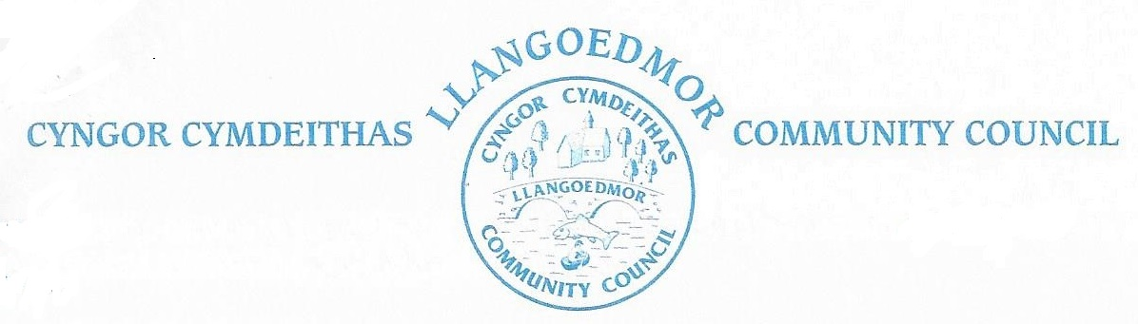

*The Finance and Governance Toolkit Committee will hold a meeting by remote means to take place at 7.00 pm on 13th February 2023 in accordance with The Local Government and Elections (Wales) Act 2021*

*Committee members are summoned to deal with the following agenda.*

*The Code of Conduct, Standing and Financial Orders will apply.*

*Members of the public and press who wish to attend the virtual meeting can find the login details at the link below.*

***Supporting documents can be found at http://llangoedmorcc.org.uk/finance-and-governance-toolkit-committee/***

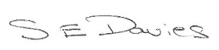

S E Davies 02-02-23

Open session for members of the public to raise any matters of relevance to the Community 7.00 - 7.15. In the event there are no members of the public present the meeting will start at 7.00 pm prompt.

**1. Election of Chairman**

**2. Apologies for Absence / Ymddiheuriadau am absenoldeb**

**3. Declarations of Interest on Matters Arising from the Agenda/Datgan Diddordeb ar faterion sy’n codi o’r Agenda**

**4. Confirmation of Order of the Agenda** and identification of any items that might be resolved for confidential session

**5**. **To examine part one of the Toolki**t and identify areas for further work **To review part two** and record **actions** to develop, or further develop, in each area.

**6.**  **Date of Next Meeting – ??**

Should there be any confidential matters arising the Council will pass the following resolution and all members of the public and press will be requested to leave the meeting at this point: *Resolution: In view of the confidential nature of the business to be discussed, the public and press be excluded from the meeting in accordance with the Public Bodies (Admission Public Bodies (Admission to Meetings) Act 1960, Section 1*

*Committee members: Cllrs J Culley, A Edwards, R Davies. Membership open to other interested Cllrs as agreed by the Council.*