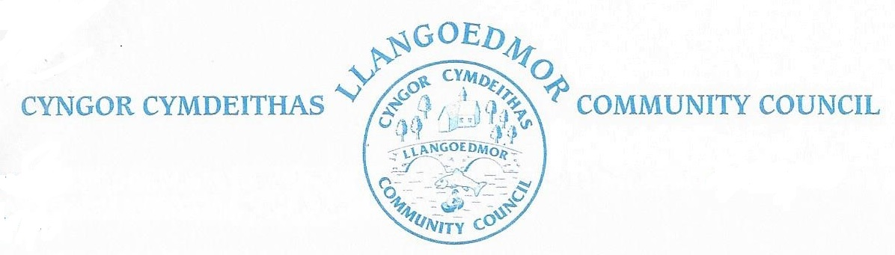

The Council will hold a meeting at the Coracle Hall, Llechryd at 7pm on April 3rd 2023 in accordance with The Local Government and Elections (Wales) Act 2021.

Members of the public and press who wish to attend the virtual meeting should contact the Clerk at llangoedmorcc@gmail.com to obtain the log in details or these can be found, with supporting documents at http://llangoedmorcc.org.uk/agenda-and-supporting-documents/

Cllrs are summoned to deal with the following agenda.
The Code of Conduct, Standing and Financial Orders will apply.
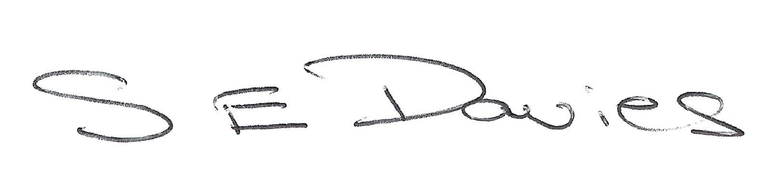

Sue Davies, Clerk to the Council

23-03-23

Open session for members of the public to raise any matters of relevance to the Community 15 minutes maximum. In the event there are no members of the public who wish to speak the meeting will start promptly after the Annual Meeting.

1. Ymddiheuriadau am absenoldeb / Apologies for Absence

2. Datgan Diddordeb ar faterion sy’n codi o’r Agenda / Declarations of Interest on Matters Arising from the Agenda

3. Confirmation of Order of the Agenda and identification of any items that might be resolved for confidential session

4. Confirmation of Minutes of 06-03-23

5. Ceisiadau Cynllunio / Planning

Planning documents can be found at: https://www.ceredigion.gov.uk/resident/planning-building-control-and-sustainable-drainage-body-sab/planning-building-control/

Planning Enforcement

LDP2 update

6. County Cllr’s Report

7. Cyllid a Gweinyddu / Finance & Administration
7.1 Monthly Payments

7.1.2 Bank Reconciliation

7.2 Year end
7.2.1 Financial risk assessment
7.2.2 Internal audit
7.2.3 Asset register

7.3 Future meetings
7.3.1 Translation at Council meetings
7.3.2 Use of Old School, Llangoedmor

7.4 Land registration

7.5 Newsletter

7.6 Update on bequest of land and to agree any response

7.7 Adroddiad Blynyddol Panel Annibynnol Cymru ar Gydnabyddiaeth Ariannol – Chwefror 2023 | Independent Remuneration Panel for Wales Annual Report - February 2023

7.8 Grants

8. Committees
The Finance and Governance Toolkit for Town and Community Councils
05-04-23 via Zoom
Committee members Cllrs J Culley, A Edwards, R Davies, C Wychwood

9. Hawliau Tramwy Cyhoeddu / Highways and Public Rights of Way
9.1 Action areas – Highways to include Croes-y-Llan
9.1.1 Bus stop Croes Y Llan
9.1.2 Crossing in Llechryd

9.2 Footpaths / open spaces
9.2.1 Registration of footpath
9.2.3 15-04-23, 10 am, Paths for Wellbeing, Celebration Event

9.3 Llechryd Bridge/River - To note current situation and agree any further actions

9.4 Diolch am 20/Thanks for 20 - Llangoedmor Community Council

10. Mwynderau/Amenities
10.1 Toilet Block – tenancy documents
Map required to show the agreed area of leased property

10.2 Play Area/Field – all decisions subject to approval by Llechryd Playing Field Association

10.2.1 Outstanding works including remedial works from ROSPA inspection 2022

10.2.2 Condition of boundary path

10.2.3 Dog Fouling
Installation of gates

10.2.4 Replacement climbing frame – will remain property of CC
Sovereign re installation issues

10.3 Church of the Holy Cross, Llechryd

10.4 Millennium building

10.5 Memorial bench for residents

10.6 Allotment provision

10.7 Bus shelters

10.8 Defibrillators
Coracle Hall
Llangoedmor

10.9 Noticeboards

10.10 Replacement bins (cover, play area)

11. Events
11.1 River Teifi clean up

11.2 Coronation Picnic, Sunday 7th May

12. Adroddiad / Meeting reports
To receive any reports.
12.1 Cllr R Davies - School Governors
12.2 Cllr A Edwards – Coracle Hall
12.3 Cllrs A Edwards and R Davies - PACT meeting
12.4 Resilience Group (to include updated information re flooding)
12.5 Cllr J Culley OVW regional committee
12.6 Cllr J Culley Ethics and Standards Committee

13. Correspondence / Gohebiaeth (to include consultation documents not covered under any other heading)

Launch of public consultation on location of new planned and urgent care hospital / Lansio ymgynghoriad cyhoeddus ar leoliad ysbyty gofal brys a wedi’i gynllunio newydd
Closing 19th May 2023

River Stakeholder Event/Digwyddiad Rhanddeiliaid Afon

Datganiad Ysgrifenedig: Iechyd Digidol Cynghorau Cymuned a Thref / Written Statement: Digital Health of Community and Town Councils

Gwobrau Gwirfoddoli Cavo Volunteer Awards 2023

14. Materion Personol / Personal Matters - Cllrs Exchange of Information / Cyfnewid Gwybodaeth

15. Date of Next Meeting – 15-05-23

The Council will pass the following resolution and all members of the public and press will be requested to leave the meeting at this point: Resolution: In view of the confidential nature of the business to be discussed, the public and press be excluded from the meeting in accordance with the Public Bodies (Admission to Meetings) Act 1960, Section 1

Lechryd Playing Fields Association

The meeting of the Llechryd Playing Field Association Charity will take place Monday 03-04-23
Immediately following the ordinary meeting of Llangoedmor Community Council

1. Apologies for Absence

2. Minutes

3. Finance / Budget
To work with Llangoedmor CC on pricing of projects

4. Maintenance and Projects

Date of next meeting 15-05-23

Llangoedmor Community Council is Sole Trustee of the above Charity and as such all Councillors may attend subject to consideration, as Cllrs, of any interests, as defined in the Code of Conduct adopted by the Community Council, he/she/they might have.

