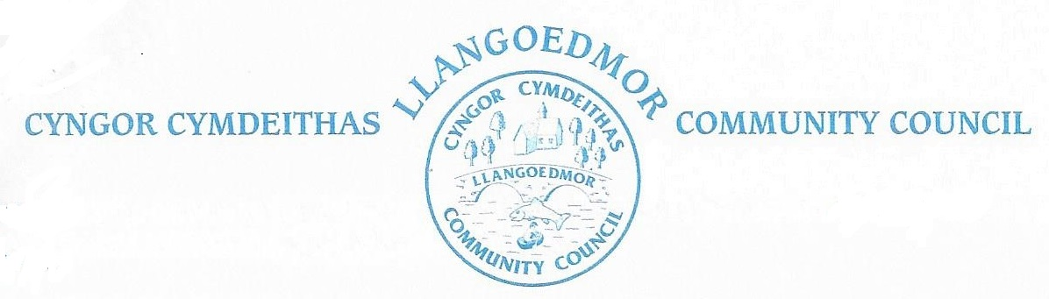

*The Finance and Governance Toolkit Committee will meet by remote means at 7.00 pm on 5th April 2023 in accordance with The Local Government and Elections (Wales) Act 2021*

*The named Cllrs are summoned to deal with the following agenda.*

*The Code of Conduct, Standing and Financial Orders will apply.*

*Members of the public and press who wish to attend the virtual meeting can find the login details at the link below.*

***Supporting documents can be found at***

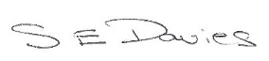

S E Davies 23-03-23

|  |  |
| --- | --- |
|  | |
| Chairman | Cllr J Culley |
| Councillors: | Cllrs R Davies, A Edwards, C Wychwood |
| Clerk | Sue Davies |
| Members of the public and press |  |

Open session for members of the public to raise any matters of relevance to the Community 7.00 - 7.15. In the event there are no members of the public present the meeting will start at 7.00 pm prompt.

**1. Apologies for Absence / Ymddiheuriadau am absenoldeb**

**2. Declarations of Interest on Matters Arising from the Agenda/Datgan Diddordeb ar faterion sy’n codi o’r Agenda**

**3. Confirmation of Order of the Agenda** and identification of any items that might be resolved for confidential session

**4. Confirmation of the minutes dated 13-02-23 as a true record.**

**5. Vision & Purpose - draft to present to CC**

**6.** [**Well-being of Future Generations (Wales) Act 2015**](https://www.legislation.gov.uk/anaw/2015/2/contents/enacted) **–** [**Section 40**](https://www.legislation.gov.uk/anaw/2015/2/section/40/enacted)

**7. Community Engagement Strategy**

**8. Policies - for refreshing / consolidating/new**

* Complaints
* IT Information security policy
* Stress management police
* Stress risk assessment policy
* Equality and Diversity Policy
* Alcohol, Drugs and Substance Misuse Policy
* Member / Officer Relations Protocol
* Recruitment Procedure
* Attendance Management Policy
* Stress Management Policy
* Time off in Lieu Policy
* Whistleblowing Policy

**9. Next steps for Committee & Council**

**10.**  **Date of Next Meeting – ???**