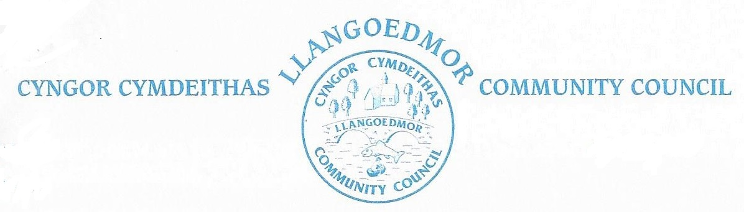

*The Finance and Governance Toolkit Committee will meet at the Coracle Hall, Llechryd at 7.00 pm on 22nd April 2023 in accordance with The Local Government and Elections (Wales) Act 2021*

*The named Cllrs are summoned to deal with the following agenda.*

*The Code of Conduct, Standing and Financial Orders will apply.*

*Members of the public and press who wish to attend the virtual meeting can find the login details at the link below.*

***Supporting documents can be found at*** *http://llangoedmorcc.org.uk/finance-and-governance-toolkit-committee/*

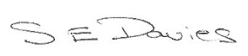

S E Davies 10-05-23

|  |  |
| --- | --- |
|  | |
| Chairman | Cllr J Culley |
| Councillors: | Cllrs R Davies, A Edwards, C Wychwood |
| Clerk | Sue Davies |
| Members of the public and press |  |

Open session for members of the public to raise any matters of relevance to the Community 7.00 - 7.15. In the event there are no members of the public present the meeting will start at 7.00 pm prompt.

**1. Apologies for Absence / Ymddiheuriadau am absenoldeb**

**2. Declarations of Interest on Matters Arising from the Agenda/Datgan Diddordeb ar faterion sy’n codi o’r Agenda**

**3. Confirmation of Order of the Agenda** and identification of any items that might be resolved for confidential session

**4. Confirmation of the minutes dated 05-04-23 as a true record.**

**5. Vision & Purpose –** 1st draft Cllr J Culley

**6.** [**Well-being of Future Generations (Wales) Act 2015**](https://www.legislation.gov.uk/anaw/2015/2/contents/enacted) **–** [**Section 40**](https://www.legislation.gov.uk/anaw/2015/2/section/40/enacted)

Ist draft Cllr C Wychwood

**7. Community Engagement Strategy –** 1st draft Cllr A Edwards

**8. Policies - for refreshing / consolidating/new**

Clerk

**9. Next steps for Committee & Council**

**10.**  **Date of Next Meeting – ???**