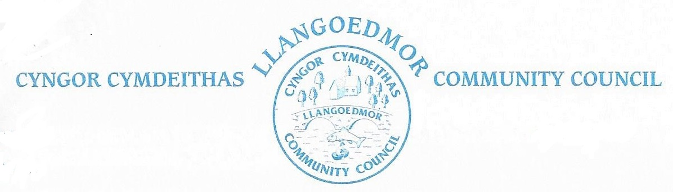

*The Council will hold its Annual Meeting at the Coracle Hall, Llechryd at 7pm on Monday 13 May 2024 in accordance with The Local Government and Elections (Wales) Act 2021. The Annual Meeting will be immediately followed by the Ordinary Meeting of the Council and the Meeting of the Llechryd Playing Field Association.*

*Members of the public and press who wish to attend the virtual meeting should contact the Clerk at* [*llangoedmorcc@gmail.com*](mailto:llangoedmorcc@gmail.com) *to obtain the log in details or these can be found, with supporting documents at* <http://llangoedmorcc.org.uk/agenda-and-supporting-documents/>

*Cllrs are summoned to deal with the following agenda.*

*The Code of Conduct, Standing and Financial Orders will apply.*

# Jan Culley, Acting Clerk to the Council

**A1. Apologies for Absence**

None.

**A2. Election of Chairman** *(please note that the term ‘Chairman’ is the only term accepted in law in the sector)*

Cllr I Davies, as Chairman, will conduct the election. He may have an original vote and be called upon to give a casting vote. After a conclusive vote he will stand down unless re-elected.

**A3. Chairperson’s Declaration of Acceptance of Office**

The Clerk will observe the Chairman signing the declaration.

Chain of Office and ‘Confidential Materials’ box to be delivered to new Chiarman by arrangement.

**A4. Declarations of Interest**

**A5. Election of Vice-Chairman**

**A6. Confirmation of Minutes of 2022 Annual Meeting**

**A7. Appointments**

|  |  |
| --- | --- |
| The Finance and Governance Toolkit for Town and Community Councils | Chairman: Cllr J Culley  Cllrs: A Edwards, R Davies, C Wychwood |
| HR Committee | Chairman: Cllr I Davies  Cllrs: R Davies, J Culley, G El Tawab |

**Council Appointments to External Bodies**

|  |  |
| --- | --- |
| School Governor | Cllr R Davies |
| Memorial Hall Committee | Cllr A Edwards |
| PACT Meeting | Cllrs A Edwards and R Davies |
| Cardigan Hospital League of Friends | Cllr K Symmons |
| OVW regional committee | Cllr J Culley |
| River Stakeholder Event/Digwyddiad Rhanddeiliaid Afon | Cllr C Lewis |

**A8. Confirmation of Standing Orders, Financial Regulations and Council Policies**

Documents and Policies may be found at: <http://llangoedmorcc.org.uk/policies/>

**A9. Finance & Administration**

Confirmation of signatories to Accounts

Currently: Cllrs I Davies, K Symmons, H Davies, and A Edwards

**Ordinary Meeting of the Council**

Immediately following the Annual Meeting the Council will hold its Ordinary Meeting.

Open session for members of the public to raise any matters of relevance to the Community 15 minutes maximum. In the event there are no members of the public who wish to speak the meeting will start promptly after the Annual Meeting.

**1. Ymddiheuriadau am absenoldeb / Apologies for Absence**

**2. Datgan Diddordeb ar faterion sy’n codi o’r Agenda / Declarations of Interest on**

**Matters Arising from the Agenda**

**3. Confirmation of Order of the Agenda** and identification of any items that might be

resolved for confidential session

**4. Confirmation of Minutes of 08-04-24**

**5.** **Update on Meeting Arrangements**

The Council will pass the following resolution if required and all members of the public and press will be requested to leave the meeting at this point: *Resolution: In view of the confidential nature of the business to be discussed, the public and press be excluded from the meeting in accordance with the Public Bodies (Admission to Meetings) Act 1960, Section 1*

**6. Ceisiadau Cynllunio / Planning**

Planning documents can be found at: https://www.ceredigion.gov.uk/resident/planning-building-control-and-sustainable-drainage-body-sab/planning-building-control/

*Planning Enforcement*

*LDP2 update*

**7. County Cllr’s Report**

**8. Cyllid a Gweinyddu / Finance & Administration**

*8.1 Monthly Payments*

*8.1.2 Bank Reconciliation*

*8.2 Year end*

*8.2.1 To note first draft documents for Year End Accounts*

*8.2.2 Internal audit*

*8.3 Future meetings*

*8.3.1 Reference to Code of Conduct, Standing Orders*

*8.3.2 Development Plan*

*8.3.3 Review of Agenda*

*8.4 Technology*

*Dedicated email*

*8.5 Land registration*

*8.6 Grants*

**9. Committees**

*The Finance and Governance Toolkit for Town and Community Councils*

Next meeting tba

Committee members Cllrs J Culley, A Edwards, R Davies, C Wychwood

*HR Committee*

Next meeting tba

Committee members Cllrs J Culley, I Davies, G El Tawab, R Davies

**10. Hawliau Tramwy Cyhoeddu / Highways and Public Rights of Way**

*10.1 Action areas – Highways to include Croes-y-Llan*

*10.1.2 Mapping for Village nameplates and speed*

*10.1.3 Crossing in Llechryd*

*10.2 Footpaths / open spaces*

*10.2.1 Llechryd Bridge/River - To note current situation and agree any further actions*

**11. Mwynderau/Amenities**

*11.1 Toilet Block – electrical test update*

*11.2 Play Area/Field – update*

*11.2.1 Replacement climbing frame – update*

*11.3 Church of the Holy Cross, Llechryd - update*

*11.4 Millennium building*

*11.5 Memorial bench for residents*

*11.6 Allotment provision*

*11.7 Bus shelters*

*11.8 Defibrillators*

*Coracle Hall - new box, recording check*

*Llangoedmor – documentation, recording check*

*11.9 Noticeboards*

*11.10 Grit bins - update*

**12. Events**

*12.1 Social*

**13. Adroddiad / Meeting reports**

To receive any reports.

*13.1 Cllr R Davies - School Governors*

*13.2 Cllr A Edwards – Coracle Hall*

*13.3 Cllrs A Edwards and R Davies - PACT meeting*

*13.4 Resilience Group (to include updated information re flooding)*

*13.5 Cllr J Culley OVW regional committee*

*13.7 Cllr C Lewis River Stakeholder Event/Digwyddiad Rhanddeiliaid Afon*

**14. Correspondence / Gohebiaeth (to include consultation documents not covered**

**under any other heading)**

**15. Materion Personol / Personal Matters - Cllrs Exchange of Information / Cyfnewid**

**Gwybodaeth**

**16. Date of Next Meeting – 03-06-24**

The Council will pass the following resolution and all members of the public and press will be requested to leave the meeting at this point: Resolution: In view of the confidential nature of the business to be discussed, the public and press be excluded from the meeting in accordance with the Public Bodies (Admission to Meetings) Act 1960, Section 1

**Llechryd Playing Fields Association**

The meeting of the Llechryd Playing Field Association Charity will take place Monday 13-05-24 immediately following the ordinary meeting of Llangoedmor Community Council.

**1. Apologies for Absence**

**2. Minutes**

**3. Finance / Budget**

**5. Maintenance and Projects**

**6. Date of Next Meeting – 03-06-24**

*Llangoedmor Community Council is Sole Trustee of the above Charity and as such all Councillors may attend subject to consideration, as Cllrs, of any interests, as defined in the Code of Conduct adopted by the Community Council, he/she might have.*