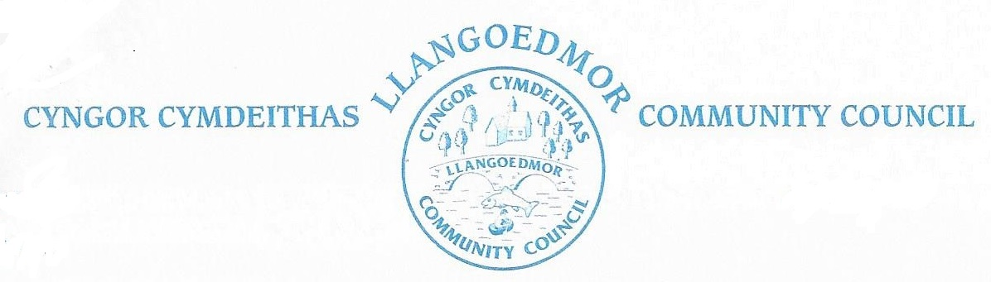

*Minutes of the Council meeting held at the Coracle Hall, Llechryd at 7pm on February 12th 2024 in accordance with The Local Government and Elections (Wales) Act 2021. Virtual access was also provided.*

# 

Present:

Cllr. Iwan Davies (Chairman), , Cllrs. Hywell Davies, Amanda Edwards, Colin Lewis, Ken Symmons,, Clive Wychwood, Ruth Davies, Garethe El Tawab

CC A Edwards

Members of the public: 0

**1. Apologies for absence**

Apologies were accepted from Cllrs. Jan Culley (Acting Proper Officer), Richard Rose.

**2. Declarations of interest on Matters arising from the Agenda.**

Cllr I. Davies declared that there was an invoice from his employers, Telemat.

**3. Confirmation of Order of the Agenda and identification of any items that might be resolved in confidential session.**

The Agenda was accepted as presented.

**4. Confirmation of Minutes of 8th January 2024**

|  |  |  |
| --- | --- | --- |
| Resolved that the minutes be accepted as a true record subject to the addition of the County Councillor’s report | Seconded |  |
| Cllr C Wychwood | Cllr H Davies | Carried |

**5. Update on Meeting arrangements.**

A motion was passed to exclude the public from the meeting.

A statement from the Acting Proper Officer relating to her discussion with the County Council’s Ethics officer was read to the meeting and accepted.

The public was re=admitted to the meeting.

**6. Planning.**

Planning documents can be found at: <https://www.ceredigion.gov.uk/resident/planning-building-control-and-sustainable-drainage-body-sab/planning-building-control>.

It was reported that Planning Application A230903, Conversion of existing guest house to dwelling, had been refused.

|  |  |  |
| --- | --- | --- |
|  |  |  |
|  |  |  |
|  |  |  |

*Planning enforcement*

Nothing brought forward.

*LDP 2 Update*

Nothing brought forward.

**7. County Councillors’ Report**

Last week we held scrutiny meetings on the budget. As a result of a lower allocation from Welsh Government than forecasted, there will be substantial savings required throughout the whole of the council. Currently we were looking at an increase of 13.9% but with a recent announcement this is looking to come down to between 11-12%

* Spoken to Osian (Rights of way Ranger) regarding issues raised in past meetings about missing waymarkers and path information. All issues have been individually logged, but current resources are an issue getting the work done. This will be put on the forward working plan and when resources become available work will commence.
* In discussion with officers regarding speeding in Llangoedmor.
* Received assistance from Kelly at Welsh Water regarding a problem with water ingress in Maeshelyg and now all sorted.
* Reported the flooding issue at Dolwylim/Cardi but the report was closed. Have requested more information as to why and what the outcome was?
* The mural that we were approached about back in the euro tournament looks like it will still be done.

**8. Finance and Administration**

*8.1 Monthly Payments*

It was noted that the payment to TJB Electricals covered three years work.

*8.1.2 Bank Reconciliation*

*8.2 Land Registration / Lease*

Deferred

*8.3 Grants Budget*

*Deferred*

*8.4 Tree survey quotation*

Specialist service so no requirement for multiple quotes. Deferred.

*8.5 Completion of requested surveys.*

**9. Committees**

*The Finance and Governance Toolkit for Town and Community Councils*

Another meeting is to be arranged.

*HR Committee*

A joint meeting of the HR Committee and the Recruitment team is to be arranged to discuss further advertising, possibly on Facebook. One enquiry has been received so far.

**10. Highways and Public Rights of Way**

*10.1 Action areas – Highways to include Croes-y-Llan*

*10.1.1 Mapping for village nameplates and speed*

. Cllr A. Edwards has a map and will arrange for copies to be made. It was proposed by Cllr R. Davies and seconded by Cllr C. Wychwood that action on new signs should. be deferred. Passed by 6 in favour, 2 against. The question of speed limits will be treated separately.

*10.1.2 Crossing in Llechryd*

Deferred.

*10.2 Footpaths / open spaces*

*10.2.1 Llechryd bridge / river.* *To note current situation and agree any further actions.*

It was reported that the island has largely been washed away and that uprooted trees are accumulating downstream.

*10.3 Hedgehog road warning signs*

**11. Amenities**

*11.1 Toilet Block*

*11.2 Play Area / Field*

No quotation yet from Groundshare.

*11.3 Church of the Holy Cross, Llechryd*

The Faculty process has started but copies of previous correspondence are required to proceed.

*11.4 Millenium Building*

*11.5 Memorial bench for residents*

Installation is in hand.

*11.6 Allotment provision*

No progress.

*11.7 Bus shelters*

The shelter at the bottom of Lady Road is being damaged by a sign. County Councillor to report.

*11.8 Defibrillators*

Coracle Hall – a new box is being investigated.

*11.9 Noticeboards*

Cllr Richard Rose reported that seals are missing from the board at the toilet block. It is not known who has the key.

*11.10 Grit Bins*

A new bin is needed opposite Cwm Coed to replace one which was there. The County Council is to be approached.

**12. Events**

*12.1 Community First Aid Grant*

Cllr. Clive Wychwood is to contact CAFOD about a grant for a training session.

*12.2 Training Plan*

The Training Plan is to be updated.

*12.3 Code of Conduct Training for Councillors*

A Group Session is to be organised.

**13. Meeting Reports**

*13.1 School Governors*

The new Head is settling in well. A welcome letter has been sent.

*13.2 Coracle Hall*

*13.3 PACT meeting*

A meeting is to be held on the 15th February.

*13.4 Resilience Group*

*13.5 OVW Regional Committees*

Cllr J. Culley reported on a productive recent meeting and stated her belief that the meetings were worthwhile.

*13.6 Ethics and Standards Committee*

*13.7 River Stakeholders Group*

Various groups are being set up. It was noted that there is a need for individual farmers to become involved.

**14.Correspondence** (to include consultation documents not covered under any other heading).

None.

**15. Personal Matters – Councillors’ exchange of information**

None.

**15. Date of next meetings**

Monday, 4th March 2024, at 7pm.

There being no further business to discuss, the meeting closed at 9 pm.