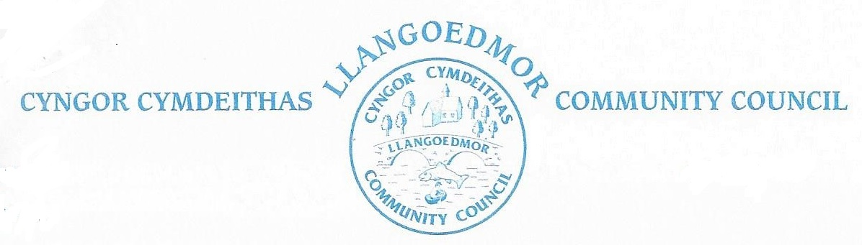

*Minutes of the Council meeting held at the Coracle Hall, Llechryd at 7pm on the 13th May, 2024 in accordance with The Local Government and Elections (Wales) Act 2021. Virtual access was also provided.*

# 

**Present**:

Cllr Jan Culley(Chairman), Cllrs Amanda Edwards, Iwan Davies, Ken Symmons, Clive Wychwood, Hywel Davies.

CC A Edwards

Clerk

Members of the public: 0

**1. Apologies for absence**

Apologies were accepted from Cllrs Colin Lewis, Garethe El Tawab, and Ruth Davies.

It was noted that Cllr R. Rose had tendered his resignation from the Council. The Council needs to advertise for a new member.

**2. Declarations of interest on Matters arising from the Agenda.**

None

**3. Confirmation of Order of the Agenda and identification of any items that might be resolved in confidential session.**

The Agenda was accepted as presented subject to a First Aid session update.

**4. Confirmation of Minutes of 8th April 2024**

Noted that Cllr Edwards name had been misspelt in item 15 and that Cllr Wychwood’s comments were clarification of comments in a previous meeting.

|  |  |  |
| --- | --- | --- |
| Proposed that the minutes be accepted as a true record | Seconded |  |
| Cllr I. Davies | Cllr H. Davies | Carried |

**5. Update on Meeting arrangements.**

No report

**6. Planning.**

No Report

*Planning enforcement*

No report

*LDP 2 Update*

Nothing brought forward.

**7. County Councillors’ Report**

Nothing to Report

**8. Finance and Administration**

*8.1 Monthly Payments*

|  |  |  |
| --- | --- | --- |
| Proposed that the tabled figures be accepted | Seconded |  |
| Cllr C. Wychwood | Cllr K. Symmons | Passed |

*8.1.2 Bank Reconciliation*

Deferred.

*8.1.3 Insurance*

It was noted that the Council’s insurance was due for renewal on 31st May 2024. This will be dealt with by Cllrs J. Culley, I. Davies and the Clerk, subject to the price increase

|  |  |  |
| --- | --- | --- |
| Proposed that the renewal of insurance is managed by Cllrs J. Culley and I. Davies | Seconded |  |
| Cllr A. Edwards | Cllr H. Davies | Passed |

*8.2 Year end*

Deferred.

*8.2.1 To note first draft documents for Year End Accounts*

Deferred.

*8.2.2 Internal audit*

Internal Audit e mails had been forwarded to the new clerk. The clerk will contact Internal Audit regarding their requirements and accounts submission.

*8.3 Future meetings*

It was proposed that the way that finance is reported be reviewed.

*8.3.1 Reference to Code of Conduct, Standing Orders*

It was noted that the Council needed a development plan for training on the Code of Conduct and the Standing Orders. It was agreed that bespoke packages of training in this area be investigated.

*8.3.2 Development Plan*

Cllrs J. Culley, I. Davies and the Clerk are to develop a plan for enhancing the finance reporting and training.

*8.3.3 Review of Agenda*

It was noted that the agenda has become very long and could be consolidated but there needs to be checks to see if there are any items that are required from a legal viewpoint.

*8.4 Technology*

*Dedicated email*

This is being taken forward by Cllr I. Davies.

*8.5 Land registration*

*This was deferred until the September meeting.*

*8.6 Grants*

Nothing to report.

**9. Committees**

*The Finance and Governance Toolkit for Town and Community Councils*

Deferred.

*HR Committee*

Meeting to be arranged.

**10. Highways and Public Rights of Way**

*10.1 Action areas – No Update.*

*10.1.1 Mapping for village nameplates and speed*

Cllr Culley to have speed map ready for the next meeting.

*10.1.2 Crossing in Llechryd*

It was decided that the public would be consulted on this matter using a Facebook page to be set up by Cllr Wychwood.

*10.2 Footpaths / open spaces*

The clerk is to investigate the current situation under CLIC reference 594169.

*10.2.1 Llechryd bridge / river.* *To note current situation and agree any further actions.*

Branches under the bridge which are usually removed in October. The clerk will log them via the CLIC account.

**11. Amenities**

*11.1 Toilet Block*

The Chair agreed to follow up with the electrician. This item will be removed from future agendas.

*11.2 Play Area / Field*

Grass cutting now needs to be taken forward. Timeline for quotes end on 17th May 2024. A Zoom meeting will be schedules for Monday 20th May at 7pm to review the quotes.

*11.2.1 Climbing Frame*

The climbing frame ifs faulty and needs to be reported on by July. The clerk has the e mail trail.

*11.3 Church of the Holy Cross, Llechryd*

This item is deferred to the July meeting.

*11.4 Millenium Building*

Cllr I Davies to take up the matter of the tree with a tree surgeon and clerk. A quote will be required for the tree work.

*11.5 Memorial bench for residents*

The memorial bench has been unavailable for collection. An e mail will be sent to arrange collection with the persons holding the bench.

*11.6 Allotment provision*

It needs to be established who is in need of an allotment.

*11.7 Bus shelters*

Remove form future agendas.

*11.8 Defibrillators*

A new box is required for the Coracle Hall. The checks that have been made on the defibrillators need to be documented and records maintained going forward.

*11.9 Noticeboards*

It was proposed that additional notice board space is purchased.

|  |  |  |
| --- | --- | --- |
| Proposed that new notice boards are purchased. | Seconded |  |
| Cllr A. Edwards | Cllr K. Symmons | Passed |

*11.10 Grit Bins*

Deferred until July.

**12. Events**

*12.1 Community First Aid Grant*

Cllr C. Wychwood outlined the plans for a Health Awareness training with the possibility of First Aid training. It was noted that a First Aid Course could be facilitated by Pembrokeshire College for £450. The event could be held over 1 or 2 days. It was noted that a grant had been available but the deadline for applying was missed before Cllr Wychwood took over the project. The project would also require the hire of the Coracle Hall and refreshments.

|  |  |  |
| --- | --- | --- |
| Proposed that Cllr Wychwood puts together plans for a 2 day Health Awareness Event. | Seconded |  |
| Cllr C. Wychwood | Cllr A. Edwards | Passed |

*12.2 Chair’s Dinner*

Cllr I. Davies is to organise the Chair’s Dinner.

**13. Meeting Reports**

*13.1 School Governors*

Nothing to report.

*13.2 Coracle Hall*

Nothing to report.

*13.3 PACT meeting*

Nothing to report.

*13.4 Resilience Group*

Nothing to report.

*13.5 OVW Regional Committees*

Concerns about CLIC had been raised with Ceredigion County Council. A OVW cost of living crisis project was being set up.

*13.6 Ethics and Standards Committee*

Nothing to report.

*13.7 River Stakeholders Group*

Nothing to report.

**14.Correspondence** (to include consultation documents not covered under any other heading).

There was no correspondence.

**15. Personal Matters – Councillors’ exchange of information**

Cllr Symmons said that a resident had their 103rd birthday shortly and it was agreed the Council should send the resident a card. The Chair will organise this.

Cllr Symmons also briefed the Council that a resident had just received their Gold Duke of Edinburgh’s Award and this need to be recognised.

**15. Date of next meetings**

Monday, 3rd June, 2024, at 7pm.

There being no further business to discuss, the meeting closed at 9 17 pm.