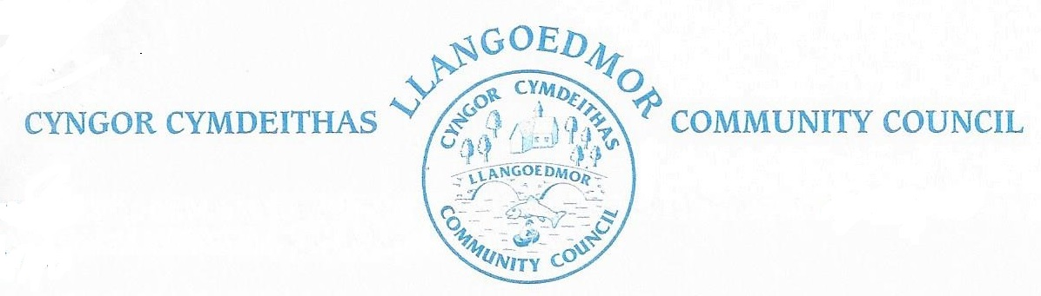

5th January, 2026

It has been decided that tonight’s meeting will be cancelled and held at a future date due to the weather.

Details of the new meeting date will be posted by the Council in the near future.

Keith Jones
Clerk.

